I shutdown the pmm-client from 08/14 14:52PM until 08/15 12:00PM on the host xsj-db04

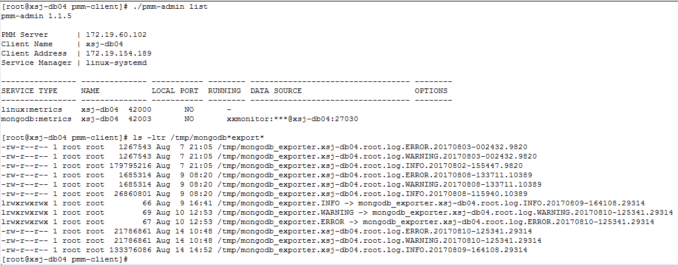
I tried to check the PMM and I could not see the xsj-db04 in the dropdown
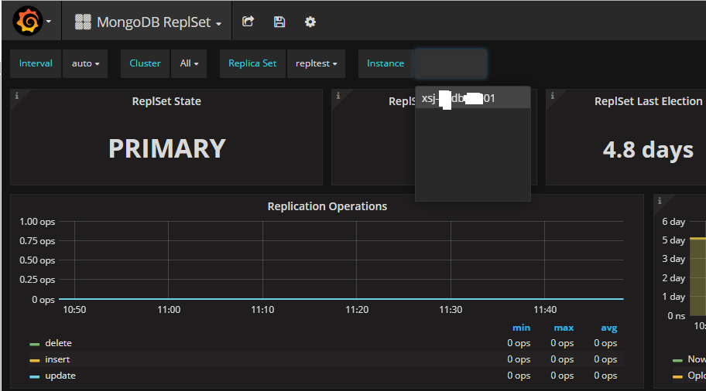

So as per your advice I tried to check for metrics between 08/14 14:30 and an hour earlier (08/14 13:30) when the pmm-client was up
I still cannot see the metrics for mongodb on xsj-db04
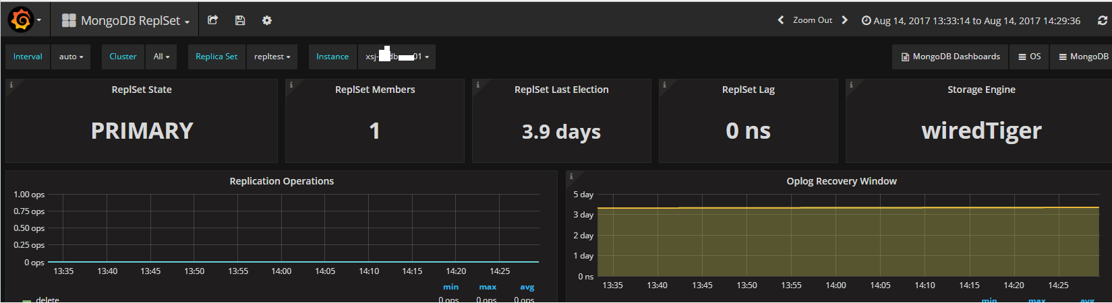

I even tried the Cross Server Graphs dash board for that time frame but xsj-db04 does not show up

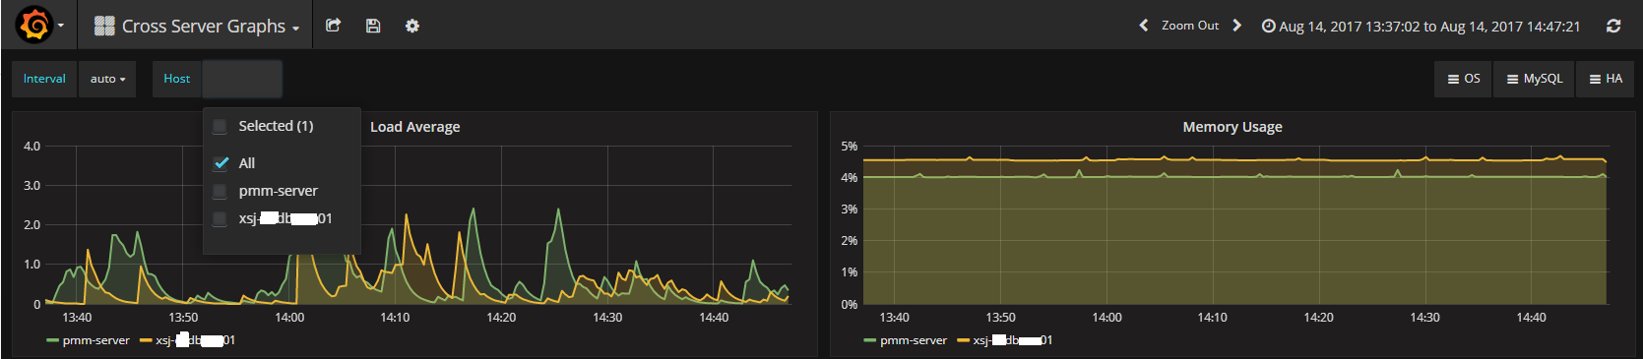

Then I started the pmm-client on xsj-db04 at 8/15 12:00PM
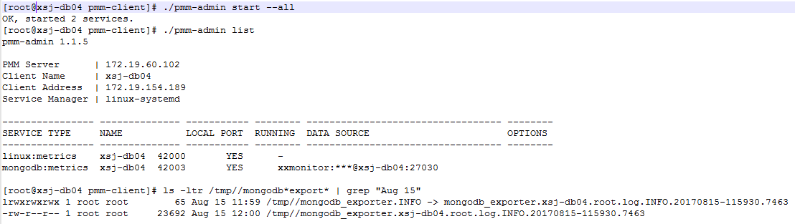
Once the pmm-client was started we could see xsj-db04 on both the dashboards
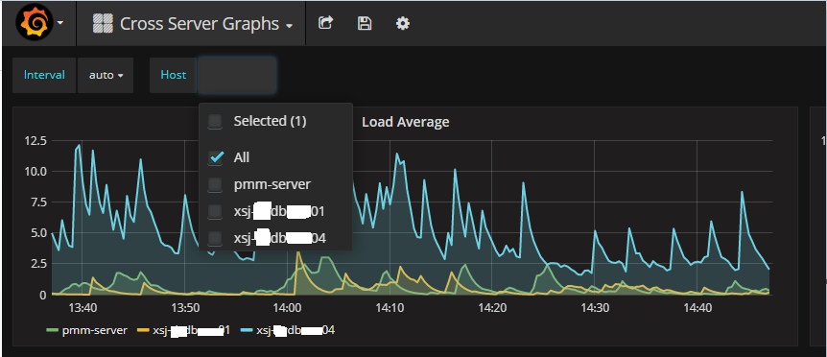

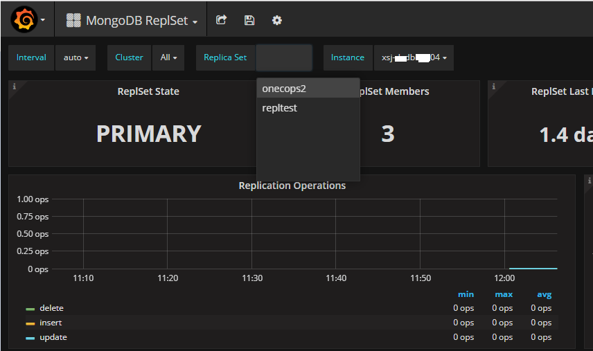

I even checked the time period when it was last up and it shows the metrics

